

LPA Simulator

User Guide

0.1.2.11

Table of Contents

1. Introduction 3

2. Requisites 3

3. Usage 3

3.1. Connect 4

3.2. Download profile 4

3.3. Enable profile 4

3.4. Disable profile 5

3.5. Delete profile 5

3.6. Set Default SM-DP+ address 5

4. Logging 5

## Introduction

The LPA Simulator is an application for managing eSIM profiles on removable eUICCs.

The current version supports the following features:

* List installed profiles
* Download new profile
* Enable profile
* Disable profile
* Delete profile
* Retrieve EID
* Retrieve Root SM-DS and Default SM-DP+ addresses
* Set SM-DP+ address

## Requisites

* Hardware
  + PC/SC Smart Card Readers
  + eSIM compatible eUICCs.
* Software
  + Windows OS or Mac OS
  + Java 1.8

## Usage

The application doesn’t need to be installed, it can simply be executed.

Once executed, the application will look like this:



## Connect

To establish a connection with the eUICC, via Smart Card Reader, the user shall select a Reader from the list and click on (Re)connect button (2).

The application will then show the eUICC information (EID and server addresses) on (4) and the profiles installed on the eUICC (6).

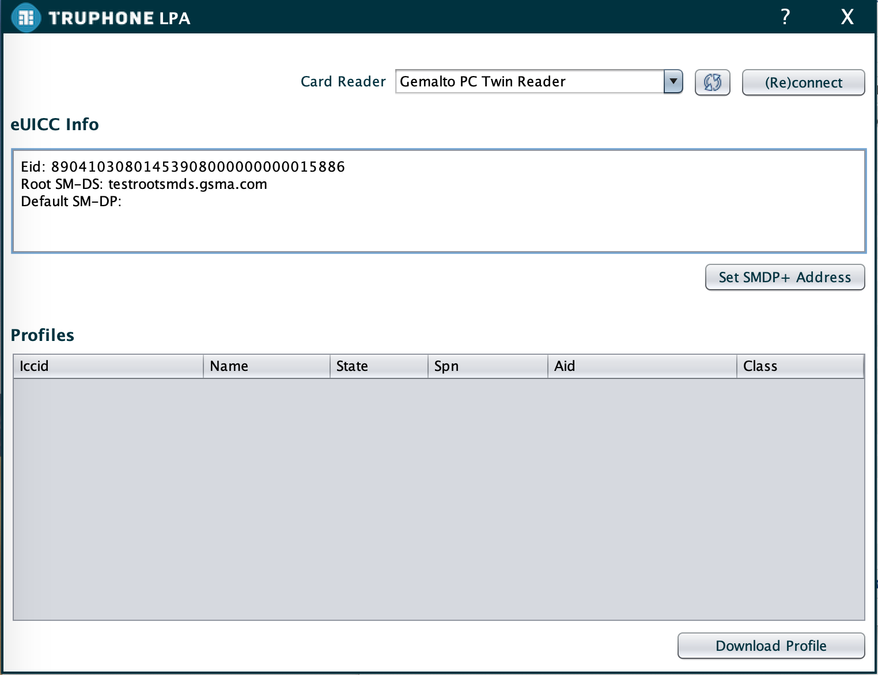

If the card is removed the user will have to press (Re)connect button again (2).

The card readers list can be refreshed at any time to detect any new card readers connected.

## Download profile

To download a new profile the user has to click Download Profile button (7) and then enter the MatchingId. The application will then download the profile from the server contained in the Activation Code.

This action may take some time. The user shall wait for the installation result.

## Enable profile

To enable a profile, the user shall select the profile, open the context menu (right click on mouse), and press Enable.

The LPA will try to enable the profile. In case of success the application will deliver any generated notifications.

## Disable profile

To disable a profile, the user shall select the profile, open the context menu (right click on mouse), and press Disable.

The LPA will try to disable the profile. In case of success the application will deliver any generated notifications.

## Delete profile

To delete a profile, the user shall select the profile, open the context menu (right click on mouse), and press Delete. The application will ask for the user to confirm the operation.

The LPA will try to delete the profile. In case of success the application will deliver any generated notifications.

If the profile to be delete is Enabled, the operation will fail.

## Set Default SM-DP+ address

To update the Default SM-DP+ server address, the user has to click Set SM-DP+ Address button(5) and enter the new value. The application will then update the eUICC.

## Logging

The application logs the information exchanged with the RSP server and the APDUs exchanged with the card to a file called lpa_log.txt. Depending on the OS, the logs may be generated in different folders. On Windows the file is created on the application’s folder. On Mac the file is created on /tmp folder.